**A MINOR PROJECT REPORT**

**On**

**URBANKART ECOMMERCE**

**Submitted by**

**Suraj Goswami (Roll No: 10800221012) Arindol Ghosh (Roll No: 10800221100)**

**Binoy Gorai (Roll No: 10800221117) Debashis Kar (Roll No: 10800221120)**

**Submitted to Asansol Engineering College in partial fulfilment of the Requirements for the degree of**

**Bachelor of Technology (Information Technology)**

**Under the guidance of**

# Mr. Santu Mondal

**(Assistant Professor)**



# Information Technology Asansol Engineering College Asansol

**Affiliated to**

**MAULANA ABUL KALAM AZAD UNIVERSITY OF TECHNOLOGY**

**01/2025**



**CERTIFICATE**

Certified that this project report on **“URBANKART ECOMMERCE”** is the bonafide work of **“Suraj Goswami (Roll No.: 10800221012), Arindol Ghosh (Roll No.: 10800221100) , Binoy Gorai (Roll No.: 10800221117), Debashis Kar (Roll No.: 10800221120)”** who carried out the project work under my supervision.

**Mr. Santu Mondal Dr . Avishek Banerjee**

Assistant Professor Head of Department Department of Information Technolgy Department of Information Technology

**Information Technology Asansol Engineering College Asansol**

ii **|** Page

**ACKNOWLEDGEMENT**

It is our great privilege to express my profound and sincere gratitude to our **project supervisor Mr. Santu** **Mondal, Assistant Professor**, for providing us with very cooperative and precious guidance at every stage of the present project work being carried out under his supervision. His valuable advice and instructions in carrying out the present study have been a very rewarding and pleasurable experience that has greatly benefitted us throughout our work.

We would also like to pay our heartiest thanks and gratitude to Dr. Avishek Banerjee, Head of the Department, and all the faculty members of the Department of Information Technology, Asansol Engineering College, for the various suggestions provided in attaining success in our work.

Finally, we would like to express our deep sense of gratitude to our parents for their constant motivation and support throughout our work.

……………………………………………

(Suraj Goswami)

…………………………………………… (Arindol Ghosh)

……………………………………………

(Binoy Gorai)

…………………………………………… (Debashis Kar )

**Date: 20/01/2025 4th Year**

**Place: Asansol Information Technology**

iii **|** Page

**CONTENT**

|  |  |
| --- | --- |
| Certificate ……………………………………………………………………... ii |  |
| Acknowledgement …………………………………………………………….. iii |  |
| Content ………………………………………………………………………… iv |  |
| List of Figures/Tables ………………………………………………………….. v |  |
| Project Synopsis ………………………………………………………………... 1 |  |
| 1. Introduction ……………………………………………………………... 2 |  |
| 2. Project Details …………………………………………………………… 3-12  2.1 Search Bar |  |
| 2.2 Register  2.3 Login  2.4 Admin Dash Board  2.5 User Module  2.6 Forgot Password  2.7 Payment Gateway  2.8 DFD  2.9 ERD  3. List of Tables …………………………………………………………… 13-15  4. List of Figures …………………………………………………………… 16-24 |  |
| 5. Conclusion and Recommendations ………………………………………. 25 |  |
| 6. Reference …………………………………………………………………. 25 |  |

iv **|** Page

**LIST OF TABLES**

|  |  |  |
| --- | --- | --- |
| Table 1 | cart | 13 |
| Table 2 | category | 13 |
| Table 3 | order_address | 14 |
| Table 4 | product | 14 |
| Table 5 | product_order | 15 |
| Table 6 | user_dtls | 15 |

**LIST OF FIGURES**

|  |  |  |
| --- | --- | --- |
| Figure 1 | Home Page | 16 |
| Figure 2 | Search bar | 17,18 |
| Figure 3 | Register | 18 |
| Figure 4 | Login | 19 |
| Figure 5 | Admin Dashboard | 19-22 |
| Figure 6 | User Module | 22,23 |
| Figure 7 | Forgot Password | 24 |

v **|** Page

**Project Synopsis :-**

UrbanKart is an innovative e-commerce platform designed to redefine the shopping experience by bridging the gap between businesses and a broader customer base. This platform empowers retailers to improve sales and profitability while providing customers with a seamless, efficient, and accessible way to shop online. Built on the robust and scalable Spring Boot API for backend architecture, UrbanKart ensures high performance, reliability, and scalability. Its frontend, developed using HTML, CSS, and JavaScript, delivers a responsive, intuitive, and visually appealing user interface. UrbanKart harmonizes the convenience of e-commerce with the trust and familiarity of traditional retail, enabling customers to purchase products from their preferred local shops online, irrespective of location. With features like home delivery and real-time tracking, the platform enhances convenience and accessibility for all users.

UrbanKart addresses the growing demand for digital shopping experiences while retaining the core benefits of physical retail. The platform offers a wide range of e-commerce functionalities, including product browsing, secure transactions, real-time order updates, and data transfer. By leveraging the powerful Spring Boot framework for its backend, UrbanKart guarantees robust performance and efficient handling of complex workflows, ensuring minimal downtime and maximum operational efficiency. Furthermore, the use of modern web development tools enhances the platform's responsiveness, ensuring a user-friendly experience for customers, retailers, and administrators alike.

The platform caters to a diverse audience that values convenience, accessibility, and reliability in their shopping experiences. Key demographics include working professionals who have limited time for traditional shopping, younger consumers accustomed to purchasing items such as clothing, electronics, and household goods online, and anyone with access to the internet and secure payment options such as credit or debit cards. Tech-savvy users who prefer to compare brands, evaluate product quality, and access services like home delivery also find UrbanKart highly appealing.

UrbanKart prioritizes customer trust by addressing critical concerns such as payment security, product authenticity, and fraud prevention. Advanced encryption protocols, secure payment gateways, and transparent order tracking are integral to the platform, fostering confidence among users. The platform also ensures accurate order fulfillment and efficient dispute resolution, further enhancing its reliability.

Beyond delivering an exceptional shopping experience, UrbanKart empowers traditional retailers by offering them a competitive edge in the digital marketplace. The platform provides businesses with tools to establish a robust online presence, enabling them to expand their reach beyond local boundaries and tap into new revenue streams. Through advanced analytics, retailers can gain valuable insights into customer preferences and market trends. These insights help optimize inventory management, refine marketing strategies, and personalize customer interactions, ultimately driving growth and improving profitability.

UrbanKart's comprehensive approach integrates cutting-edge technology, user-friendly design, and business-oriented features, making it a vital tool for modern commerce. Its adaptability allows small local shops to scale operations while providing large multinational chains with a streamlined, feature-rich solution tailored to their extensive needs. UrbanKart combines convenience, security, and business empowerment, making it the perfect solution for meeting the evolving demands of the e-commerce landscape.

Whether enhancing the local shopping experience or serving as a robust platform for global commerce, UrbanKart redefines the boundaries of traditional and digital retail. Its seamless integration of functionality, security, and customer satisfaction positions it as a transformative force in the modern retail ecosystem.

1 **|** Page

**Introduction**

The UrbanKart e-commerce platform is a comprehensive solution designed to deliver a seamless and efficient shopping experience. By integrating advanced features that cater to the needs of both customers and administrators, UrbanKart establishes itself as a versatile and reliable platform for modern retail. Its user-centric design and robust architecture ensure a satisfying experience for all stakeholders.

One of the platform's most notable features is its advanced search functionality. Customers can filter products based on specific criteria, such as category, price range, brand, or keywords, allowing them to locate desired items quickly and efficiently. This intuitive search system saves time and enhances the overall user experience by eliminating unnecessary browsing, making it easier for users to find exactly what they need.

UrbanKart supports multi-role functionality, allowing for the seamless operation of various user roles, including customers and administrators. Customers have access to features such as product browsing, placing orders, and managing their accounts. On the administrative side, the platform provides tools for managing product inventories, processing orders, monitoring system performance, and analyzing business metrics. This role-based approach ensures that each user has access to the tools and features most relevant to their specific needs, enhancing both user satisfaction and operational efficiency.

A key component of UrbanKart is its robust account management system, which is tailored to serve both customers and administrators. Customers can create and customize their profiles, view their order history, save favorite items, and securely manage payment methods. Administrators, on the other hand, can monitor user activity, manage permissions, and resolve customer support queries efficiently. This dual functionality ensures that the platform caters to the unique requirements of its diverse user base.

Real-time order tracking is another standout feature of UrbanKart. Customers can monitor the status of their orders at every stage, from placement to delivery, with regular updates provided in real-time. This level of transparency builds trust, as customers are consistently informed about the progress of their purchases, ensuring a positive and worry-free shopping experience.

The platform also employs automated email notifications to keep users informed and engaged. Customers receive updates regarding order confirmations, shipping details, promotional offers, and personalized reminders. These notifications not only enhance customer engagement but also provide an additional layer of convenience. For administrators, automated alerts ensure timely responses to critical issues, such as low stock levels, system errors, or customer inquiries, contributing to smoother operations and improved management.

UrbanKart prioritizes security and reliability, addressing common customer concerns such as payment security and product authenticity. The platform incorporates advanced encryption protocols and secure payment gateways to protect sensitive user data. By fostering a safe shopping environment, UrbanKart builds trust and loyalty among its users.

In addition to enhancing the shopping experience, UrbanKart empowers administrators and business owners with tools to optimize operations. Advanced analytics enable businesses to understand customer preferences, track sales trends, and refine marketing strategies. This data-driven approach helps businesses improve profitability while delivering a tailored shopping experience.

UrbanKart’s comprehensive set of features—spanning user convenience, operational efficiency, and data security—positions it as a leading solution for modern e-commerce. It caters to the evolving needs of customers and businesses alike, ensuring a seamless and rewarding experience for all users.

2 **|** Page

**Project Details:-**

* **2.1 Search Bar:**

The described functionality involves creating a search bar for an e-commerce platform (Urban Kart) using Spring Boot, HTML, and CSS. The search functionality is divided into two modes based on user authentication:

1. Without Login

Accessible Features: The search bar will allow users to search by category and product name.

Scope:

Publicly available data is searchable (e.g., product categories and names).

It ensures that unauthorized users cannot access sensitive information, such as order history or product details linked to a specific user.

2. With Login

Accessible Features:

Users can search products displayed on the product listing pages . Users can search for their past orders using unique Order IDs . Users can search for specific products using unique Product IDs.

Scope:

Logged-in users gain access to personalized data, such as their orders. More refined search options enhance the user experience by enabling users to retrieve specific information efficiently.

Key Components of the Search Bar

1. Frontend (HTML/CSS):

A simple, responsive search bar integrated into the e-commerce platform's UI.Placeholder text and dropdown filters for category or product selection.

2. Backend (Spring Boot):

RESTful endpoints to handle search requests. Service classes with business logic for querying the database.

3. Database:

Product tables for categories, names, and IDs. Order tables to retrieve user-specific order details.

3**|** Page

* **2.2 Register:**

1. User Information Collection:
   * The module provides input fields for collecting essential user details such as username, email, password, and an option to upload a profile image.
   * The password field includes real-time strength indicators to guide users on creating secure passwords.
2. Password Encoding:
   * Passwords are securely encoded using Spring Security's BCryptPasswordEncoder.
   * This ensures that passwords are hashed and salted, providing protection against breaches and ensuring compliance with modern security standards.
3. Image Upload:
   * Users can upload profile images with validation checks such as file size and type restrictions to ensure secure handling.
   * Uploaded images are securely stored either in a dedicated directory or a database, ensuring they are only accessible to authorized users.

Implementation

1. Frontend:
   * The user interface is designed using HTML and CSS to provide a clean and intuitive form for data collection.
   * Features include:
     + Text input fields for username, email, and password.
     + File upload functionality for profile images.
     + Real-time password validation to check for minimum length, complexity, and other security criteria.
     + Image preview functionality to let users see their profile pictures before submission.
2. Backend:
   * Spring Boot serves as the backend framework, efficiently handling form submissions and business logic.
   * Key functionalities include:
     + Validating user inputs to ensure data integrity.
     + Encoding passwords with BCryptPasswordEncoder before storing them in the database.
     + Storing user data and image paths securely, with robust error handling to manage issues such as invalid inputs or duplicate entries.
3. Security:
   * Security is a priority, and the following measures are implemented:
     + HTTPS is enabled to encrypt data transmitted between the client and the server.
     + CSRF protection prevents unauthorized actions by malicious actors.
     + File uploads are validated to reject potentially harmful files, ensuring only safe content is processed and stored.
     + Regular monitoring and updates are conducted to address potential vulnerabilities in dependencies or configurations.

4 **|** Page

* **2.3 Login:**

A **Login Module** is a critical component in modern web applications, serving as the gateway for user authentication and authorization. It ensures secure access to system resources by verifying the credentials provided by users. Below is a detailed explanation of the login module's key components and their functionality when implemented using HTML, CSS, and Spring Security.

Frontend: HTML and CSS:

HTML (HyperText Markup Language):

HTML is used to structure the login page. Key components of the login page include:

* **Form Element**: A form that collects user inputs such as username and password.
* **Input Fields**: Textboxes for username and password.
* **Submit Button**: A button to submit the credentials for validation.
* **Error Messages**: Areas to display validation errors or feedback, such as "Invalid credentials."

CSS (Cascading Style Sheets):

CSS is used to style the login page for better usability and aesthetics. It includes:

* **Responsive Design**: Ensuring the page looks good on all devices (mobile, tablet, desktop).
* **User-Friendly Elements**: Adding hover effects, transitions, and visually clear error messages.

Backend: Spring Security:

1. **Authentication**

* **User Credentials Validation**: Spring Security verifies the provided username and password against a predefined database or an in-memory authentication manager.
* **Password Encryption**: Passwords are encrypted using hashing algorithms (e.g., bcrypt) to enhance security.

**b. Authorization**

* **Role-Based Access Control (RBAC)**: Users are granted roles (e.g., ADMIN, USER) that define their access level within the application.
* **URL Protection**: Access to specific endpoints is restricted based on roles, ensuring unauthorized users cannot access protected resources.

**c. Security Features**

* **CSRF Protection**: Prevents Cross-Site Request Forgery attacks by embedding tokens in forms.
* **Session Management**: Ensures secure handling of user sessions, including timeout and session invalidation.
* **Error Handling**: Displays appropriate error messages for invalid login attempts or access denial.

5 **|** Page

* **2.4 Admin Dashboard:**

The Admin Module is a core component of the project that provides a centralized interface for managing the platform’s operations. It allows administrators to perform critical tasks such as managing products, categories, users, and other administrative functions efficiently. Below is a detailed explanation of its key features and functionalities:

**1. Add Product**

* Administrators can add new products to the system.
* Key inputs include:
  + Product name
  + Description
  + Price
  + Stock quantity
  + Product images
  + Category selection
* Validation ensures that all required fields are filled before submission.
* Products are automatically listed in the corresponding category upon successful addition.

**2. Add Category**

* Enables the creation of new categories to organize products.
* Key inputs include:
  + Category name
  + Description
* Admins can view a hierarchical structure of categories for better organization.
* Newly created categories are immediately available for product association.

**3. View Products**

* Displays a list of all products with details such as:
  + Product name
  + Price
  + Stock status
  + Associated category
* Includes search and filter functionality for efficient product management.
* Allows admins to update or delete products as required.

**4. Manage Orders**

* View and manage user orders.
* Features include:
  + Order status updates (e.g., Pending, Shipped, Delivered)
  + Viewing detailed order information, including user details and payment status.
* Admins can filter orders by date, status, or user.

**5. Manage Users**

* Displays a list of all registered users with their status.
* Features include:
  + View user details (e.g., name, email, login activity).
  + Toggle active/inactive status to control user access.
  + Filter users by status or activity for quick identification.

6 **|** Page

**6. Admin Roles and Permissions**

* **Super Admin**:
  + The highest level of administrative access.
  + Can manage all other admins and their permissions.
  + Cannot be edited or deleted by any other admin.
* **Admin**:
  + Regular administrators with limited permissions as defined by the Super Admin.
  + Can perform tasks such as adding products, managing orders, and viewing users.
* Role-based access control ensures security and proper task allocation.

**7. Add Admin**

* Allows the Super Admin to add new admins.
* Key inputs include:
  + Admin name
  + Email
  + Password
  + Assigned role and permissions
* New admins can log in and perform tasks based on their defined permissions.
* Super Admin ensures secure onboarding of new administrators.

**Security and Validation**

* All sensitive operations, such as adding products or managing users, are protected with role-based access control.
* Input validation ensures data integrity and prevents errors during entry.
* The system maintains a detailed activity log to track all administrative actions.
* **2.5 User Module:**

The User Module is a foundational component of any e-commerce system, playing a crucial role in facilitating smooth interactions between users and the platform. This module provides a range of essential functionalities that enhance user experience and ensure efficient system operation. Key features include secure user authentication, enabling users to log in safely and access personalized features. It allows users to manage products in their shopping cart effectively, with options to add, update, or remove items. Additionally, users can update their profiles to maintain accurate information such as contact details and delivery addresses. The module also supports order tracking, giving users access to real-time information.

* Ensures secure access to the system using login credentials (username and password).
* Authentication validates user identity and initiates a session for interaction.
* Upon successful login, the system personalizes the user interface based on the logged-in user's data.

7 **|** Page

**2. Add Product to Cart**

* Logged-in users can browse available products and add desired items to their cart.
* Each cart item includes details such as product name, price, quantity, and subtotal.
* Users can manage their cart by:
  + Updating quantities.
  + Removing items.
* Cart details are dynamically updated and saved to the database for future access.

**3. User Profile Update**

* Users can update their personal information such as name, email, address, and phone number.
* A dedicated profile section provides editable fields to ensure accurate and up-to-date data.
* Updated information is securely stored in the database and used for personalized recommendations and order delivery.

**4. Logout**

* The logout feature ends the user's session securely.
* Upon logout, the system clears the user's session data to prevent unauthorized access.
* Redirects the user to the homepage or login screen.

**5. View Orders**

* Logged-in users can view their order history.
* Each order includes details like order ID, product list, total amount, payment status, and delivery status.
* This feature enhances user engagement by providing a comprehensive order management experience.

**6. Cart and Payment**

* Users can view the items added to their cart and proceed to checkout.
* During checkout, users select a payment method (e.g., credit card, UPI, or wallet).
* Once payment is successful:
  + The order is confirmed.
  + The cart is cleared.
  + Order details are stored in the database for tracking and history.
* **2.6 Forgot Password:**

The Forgot Password module is a vital feature that allows users to recover access to their accounts if they forget their password. This process involves a few simple, secure steps to ensure that the password reset is handled safely. Below are the key steps involved in the process:

**Steps for Password Recovery:**

1. **Initiate Password Reset Request**:
   * The user clicks on the "Forgot Password" link located on the login page.
   * A form appears where the user is asked to enter the email address associated with their account.
2. **Email Verification**:
   * After submitting the email address, the system verifies whether it matches an existing account in the database.
   * If the email address is valid, the system proceeds to the next step. If not, an error message is displayed.

8 **|** Page

1. **Send Password Reset Link**:
   * Upon successful verification, the system generates a password reset link.
   * A notification email containing this secure, time-sensitive link is sent to the user’s registered email address.
   * The email may also include instructions for further steps to ensure clarity.
2. **User Accesses the Reset Link**:
   * The user receives the email and clicks on the password reset link.
   * The link redirects the user to a secure page where they can enter a new password.
3. **Create a New Password**:
   * On the password reset page, the user enters their new password, which must meet security criteria (e.g., minimum length, combination of letters, numbers, and special characters).
   * The user is prompted to confirm the new password for accuracy.
4. **Password Reset Confirmation**:
   * After successfully setting the new password, the system confirms the reset and alerts the user that their password has been updated.
   * The user can now log in with the new password.
5. **Login with New Password**:
   * The user returns to the login page, enters their email and the new password, and gains access to their account.

* **2.7 Payment Gateway:**

The **Payment Gateway Module** is an integral part of the e-commerce system, ensuring secure, efficient, and seamless payment processing for users. It facilitates transactions while integrating features for enhanced user convenience and communication. Below are the core functionalities of the module explained in detail:

**1. User Registration and Payment Initialization**

* Registered users can proceed to payment after completing the checkout process.
* The system ensures that the user provides accurate and complete payment details, such as card information, UPI ID, or wallet credentials.
* Payment information is encrypted and securely transmitted to the payment gateway for processing.

**2. Dynamic Quantity Management**

* Users can modify the quantity of products directly from the cart before proceeding to payment.
* The system dynamically recalculates the total cost based on the updated quantities.
* This feature ensures flexibility and enhances the shopping experience.

9 **|** Page

**3. Email Notifications**

* For every purchase, the system sends a detailed email notification to the user.
* The notification includes:
  + Product details: Name, quantity, and price.
  + Payment status: Successful, pending, or failed.
  + Order summary: Total amount and delivery details.
* Notifications serve as a record of transactions and build user trust in the system.

**4. Secure Payment Processing**

* The module integrates with third-party payment gateways to facilitate secure transactions.
* Supports multiple payment options like credit/debit cards, net banking, UPI, and digital wallets.
* Fraud prevention measures and encryption ensure user data confidentiality.
* **2.8 Data Flow Diagram ( DFD):** A user-perspective Data Flow Diagram (DFD) depicts how users interact with the system for browsing, purchasing, and managing orders.

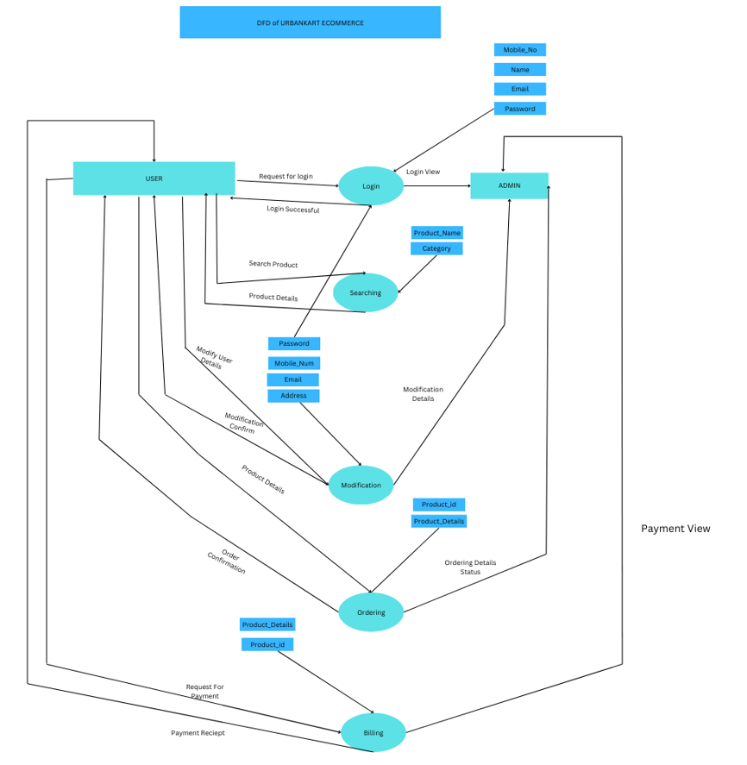

10 **|** Page

A Data Flow Diagram (DFD) for admins shows data processes like user management, product catalog updates, order monitoring, and analytics.

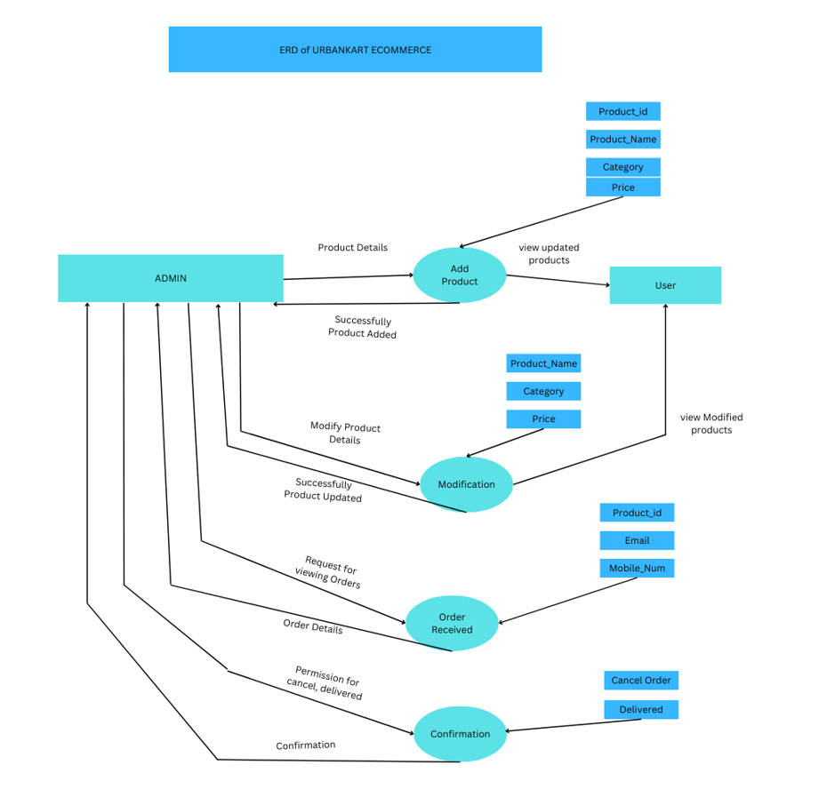

11 **|** Page

* **2.9 Entity Relationship Diagram ( ERD):**

An Entity-Relationship Diagram (ERD) for UrbanKart e-commerce represents the data structure for managing entities like Users, Products, Orders, Categories, Cart, Payments, and Reviews. It shows relationships such as Users placing Orders, Orders containing Products, Products belonging to Categories, and Payments linked to Orders, enabling a streamlined shopping experience.

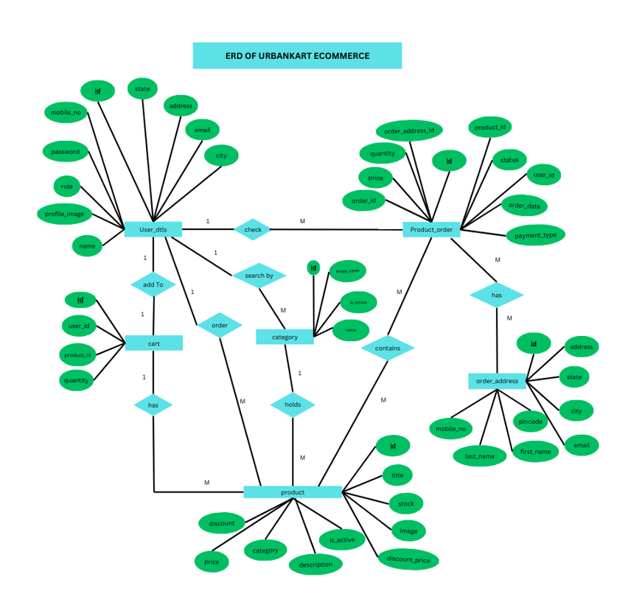

12 **|** Page

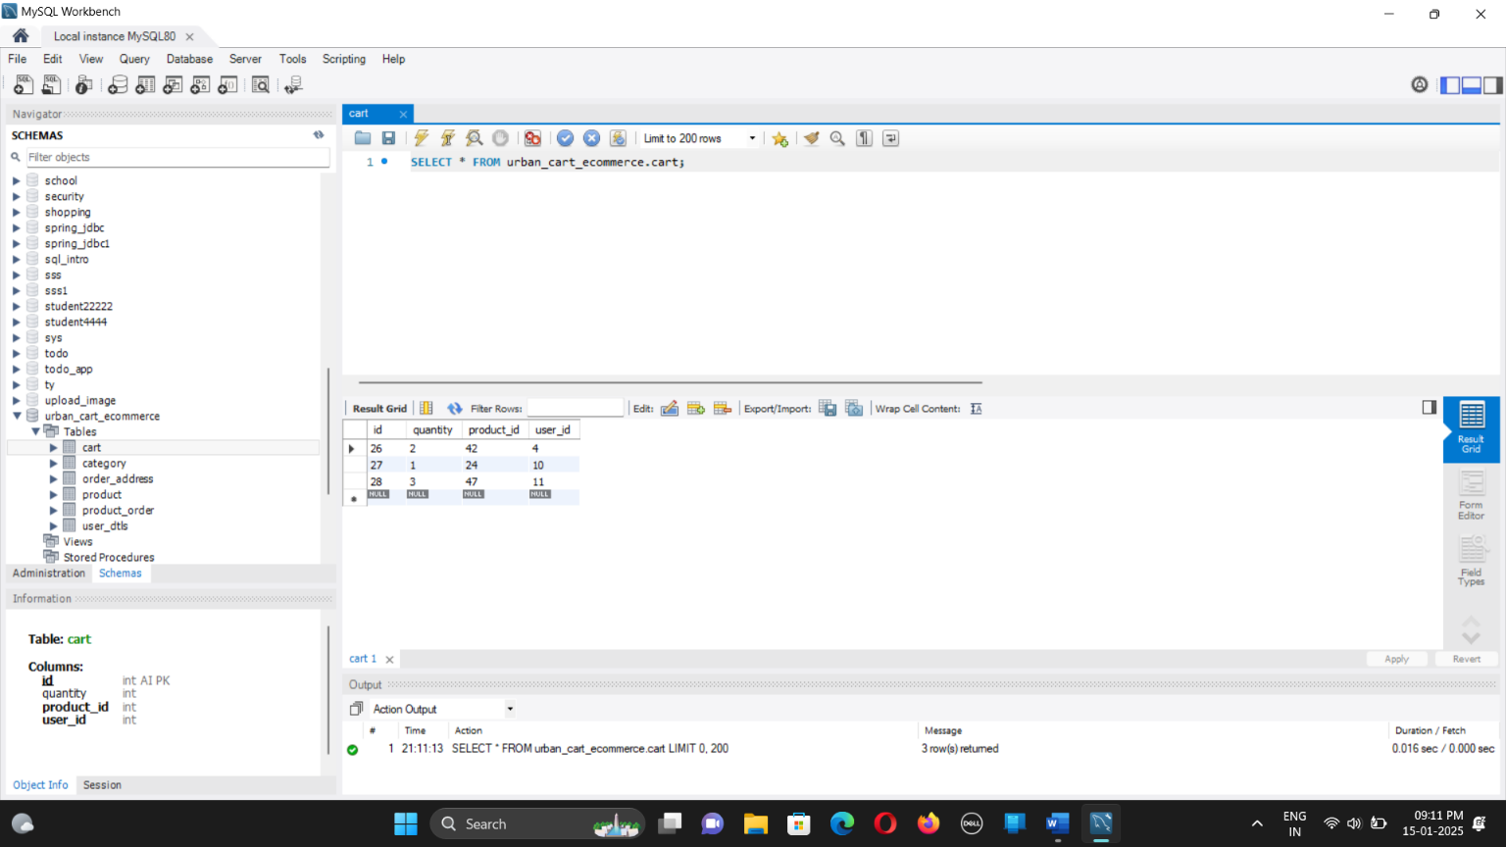

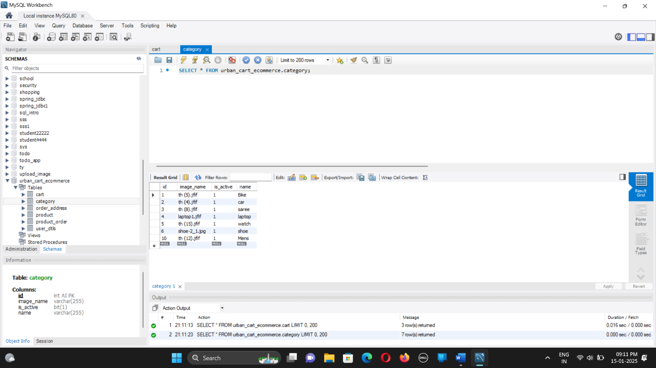

13 **|** Page

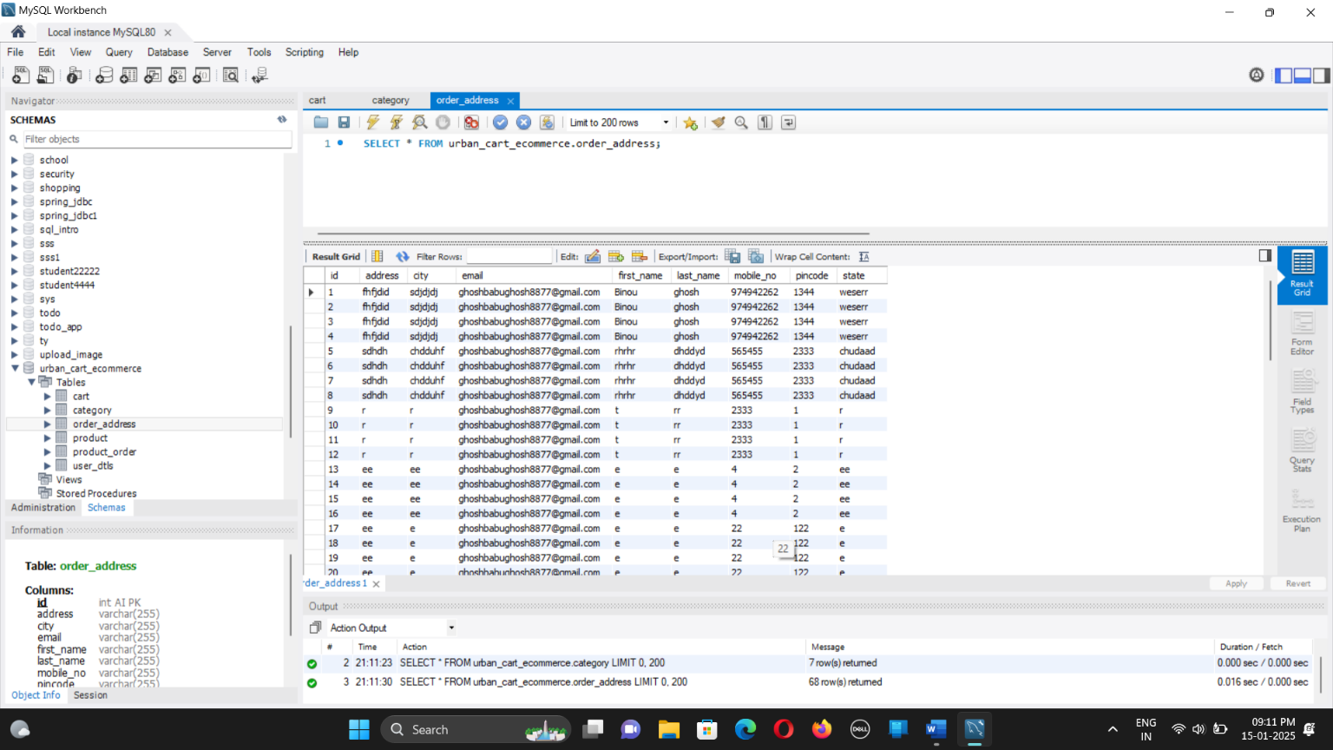

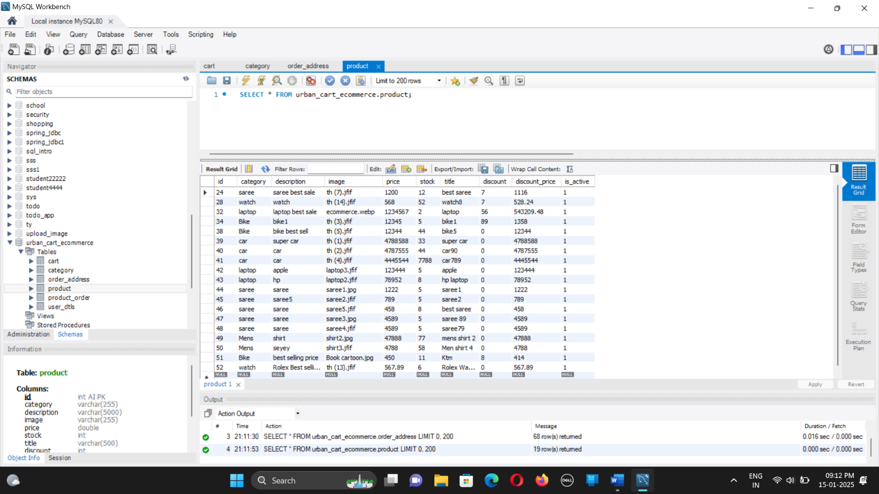

14 **|** Page

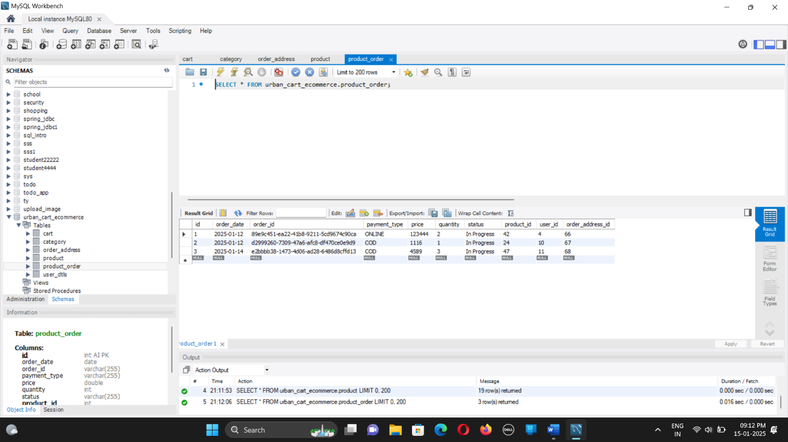

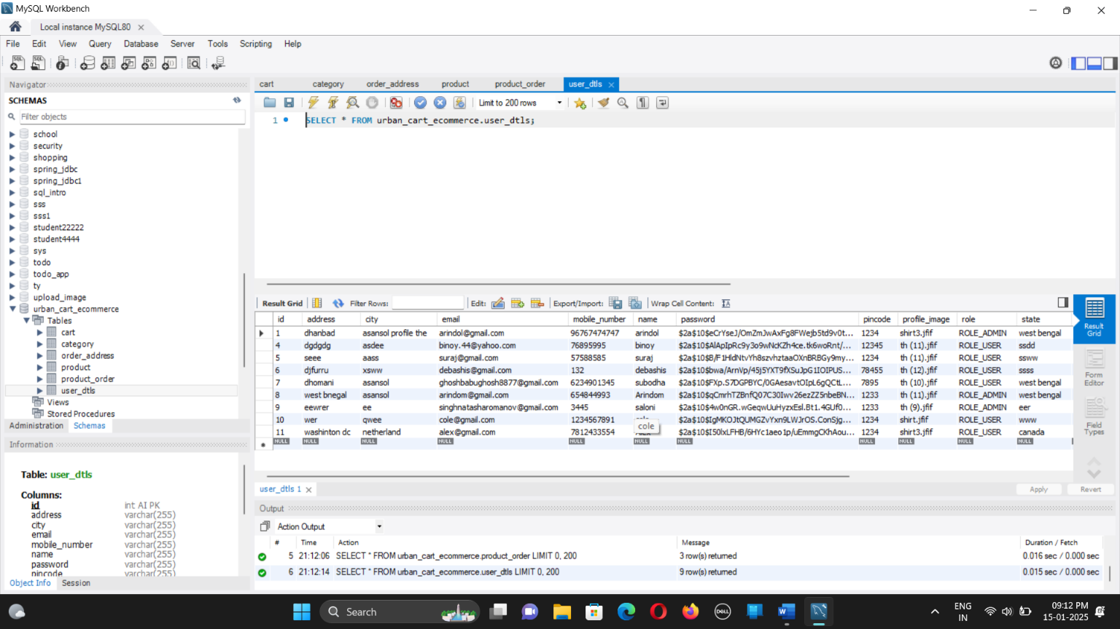

15 **|** Page

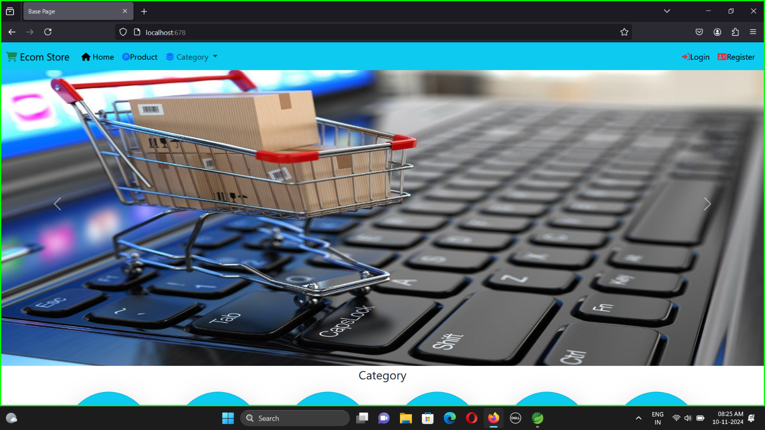

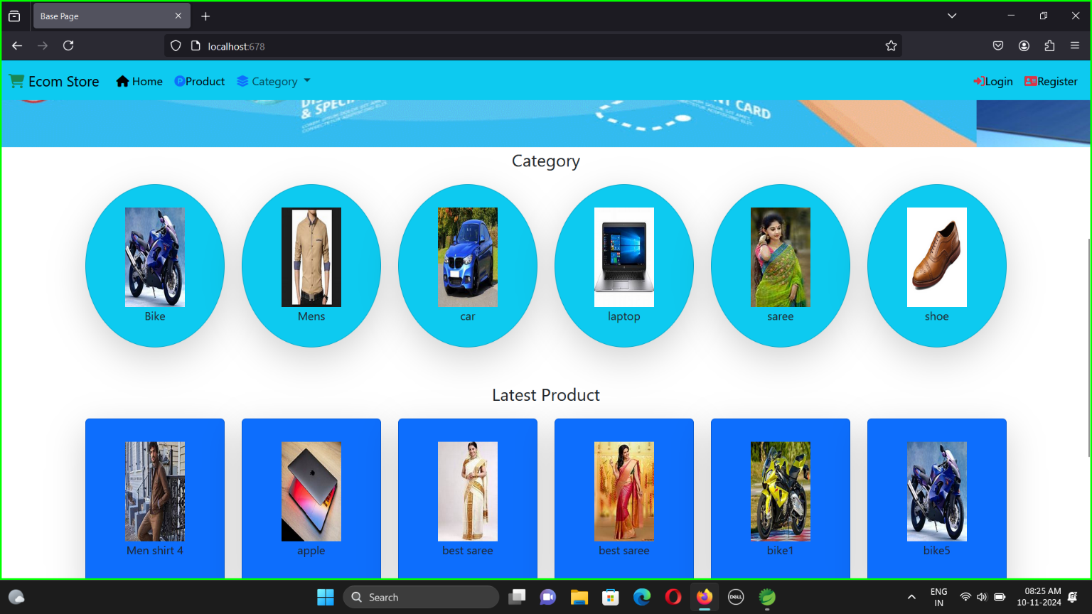

16 **|** Page

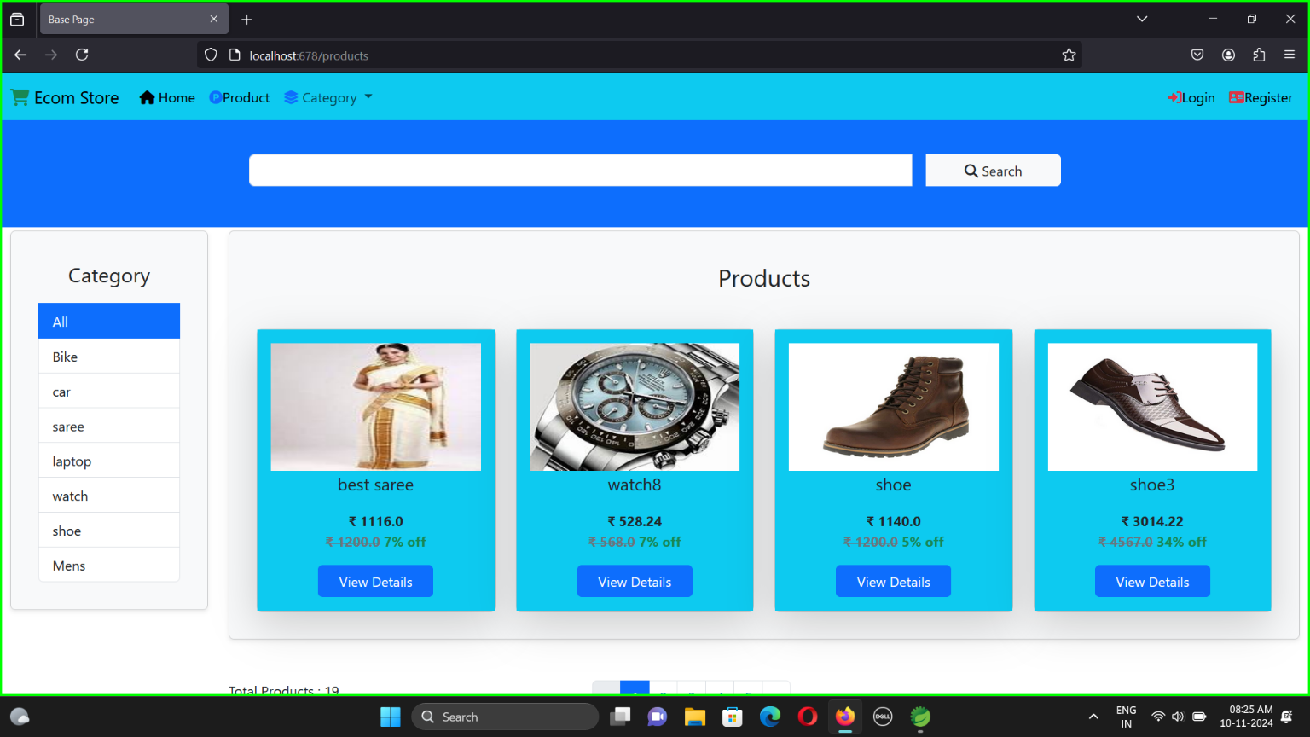

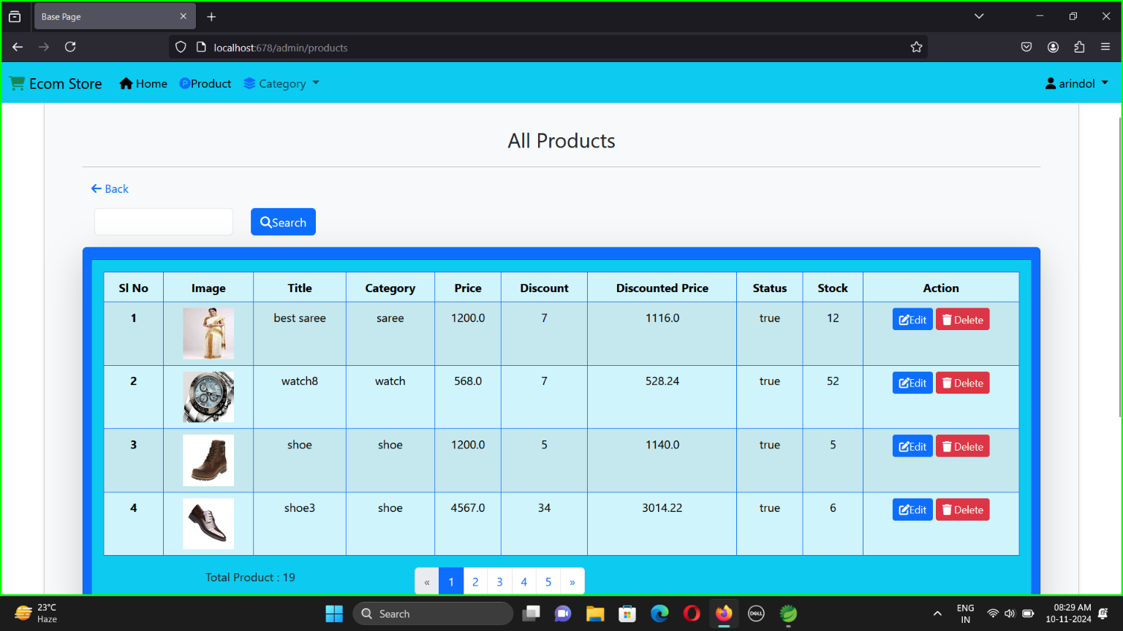

17**|** Page

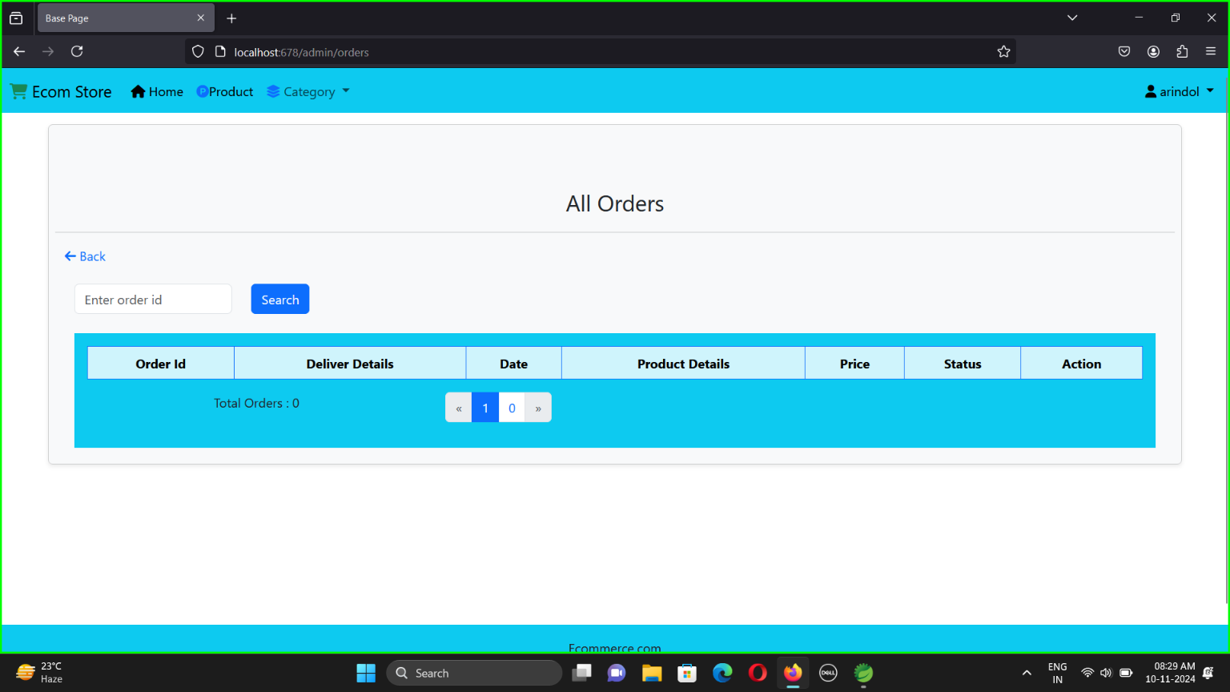

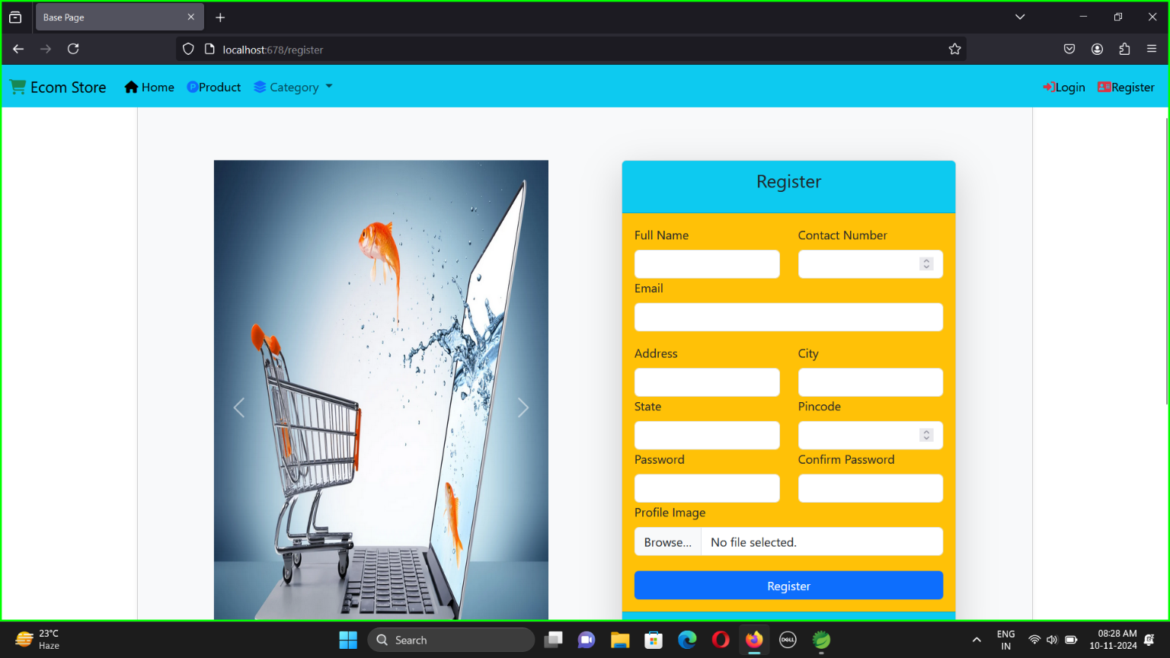

18 **|** Page

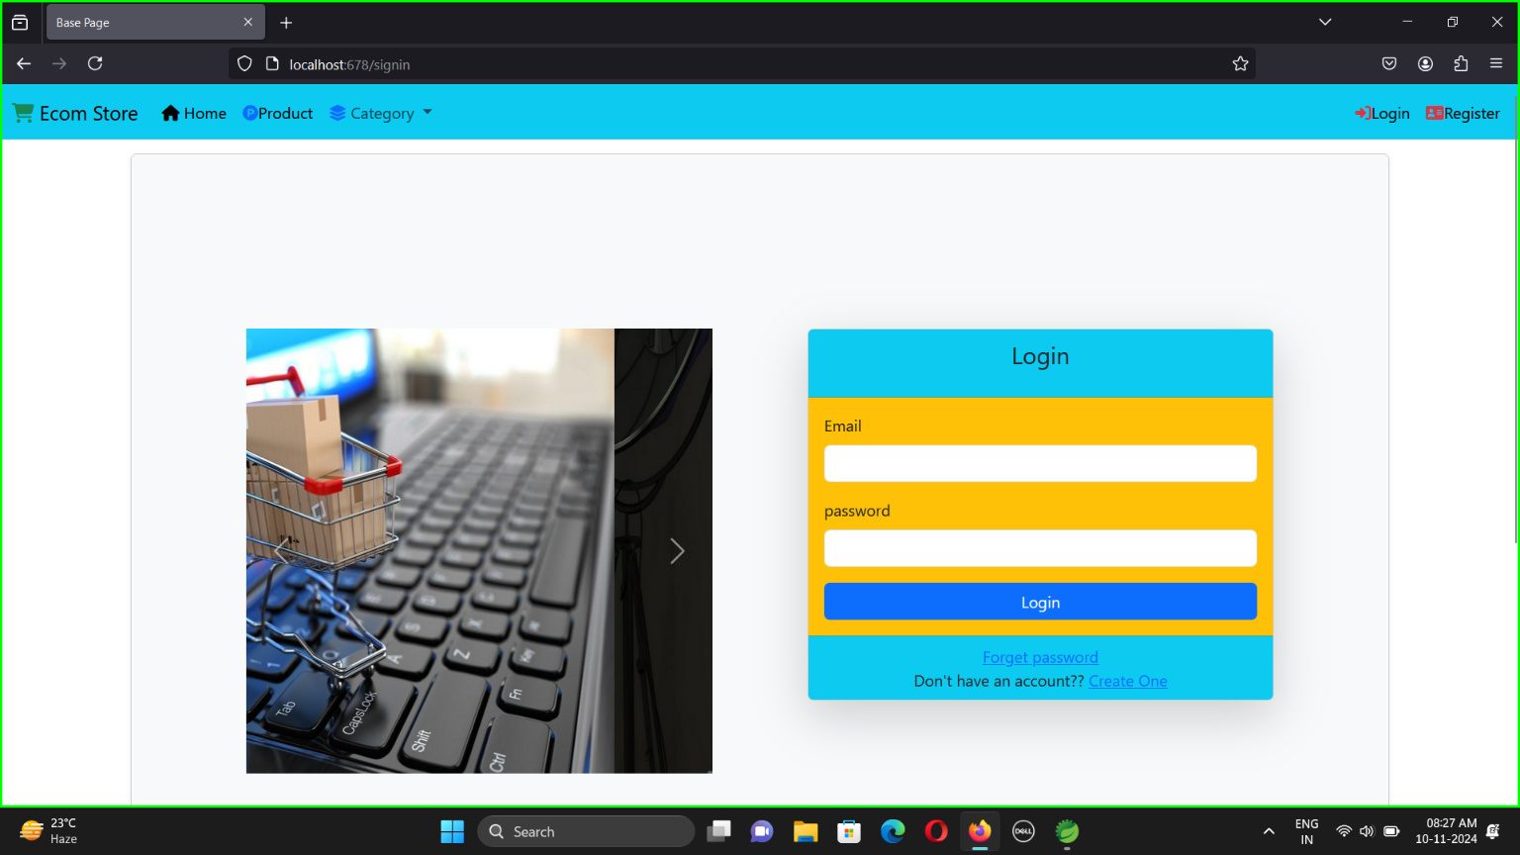

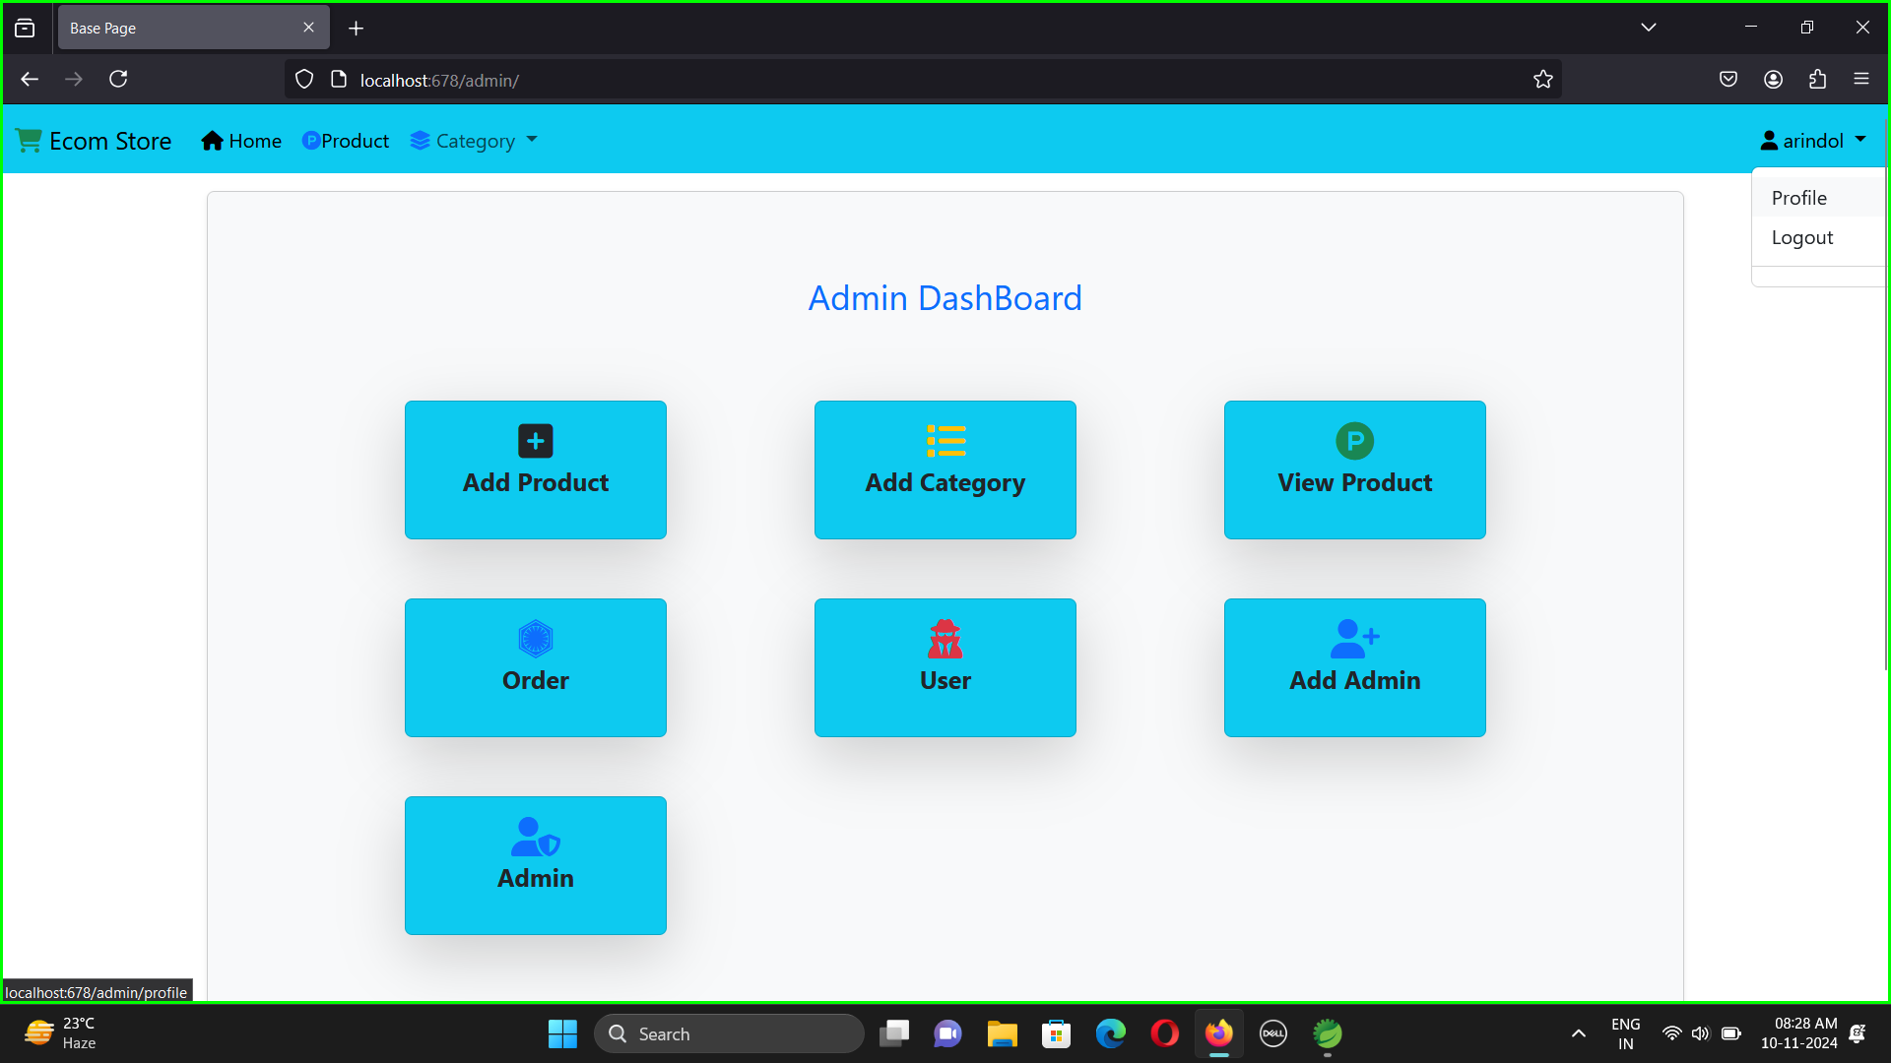

19 **|** Page

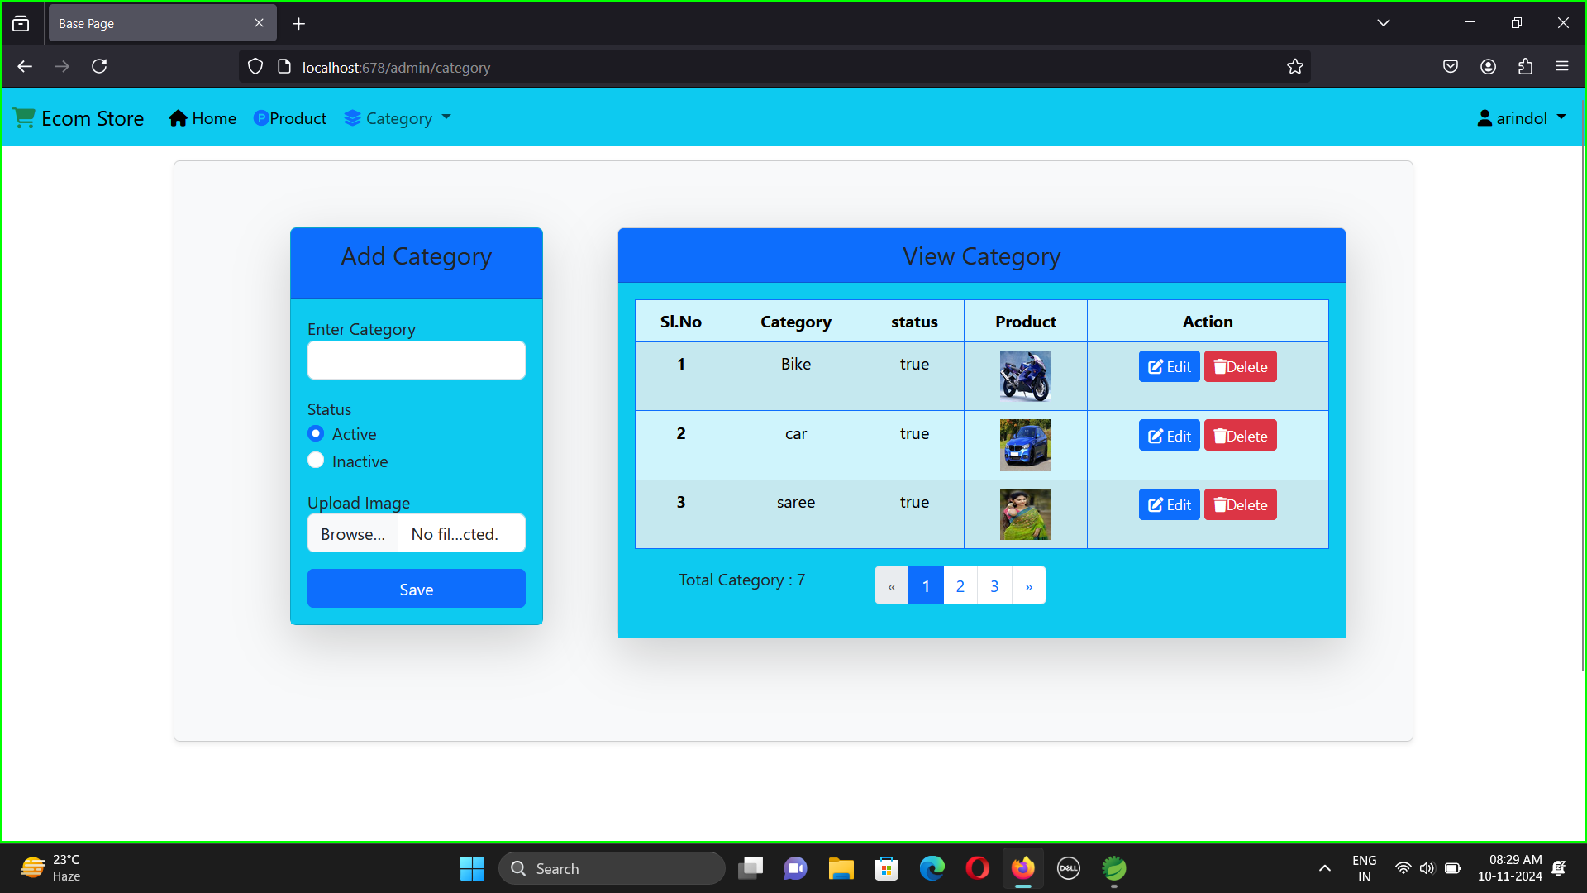



2 **0|** Page

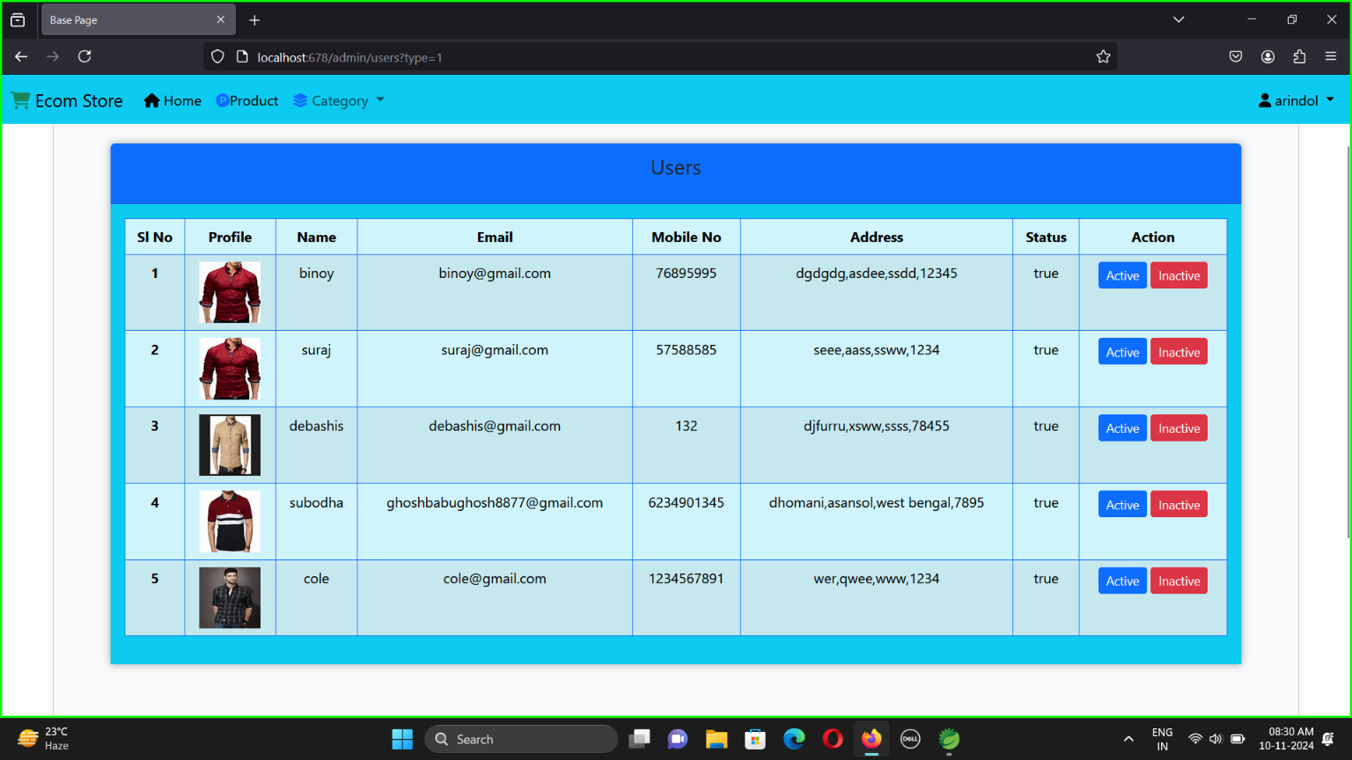

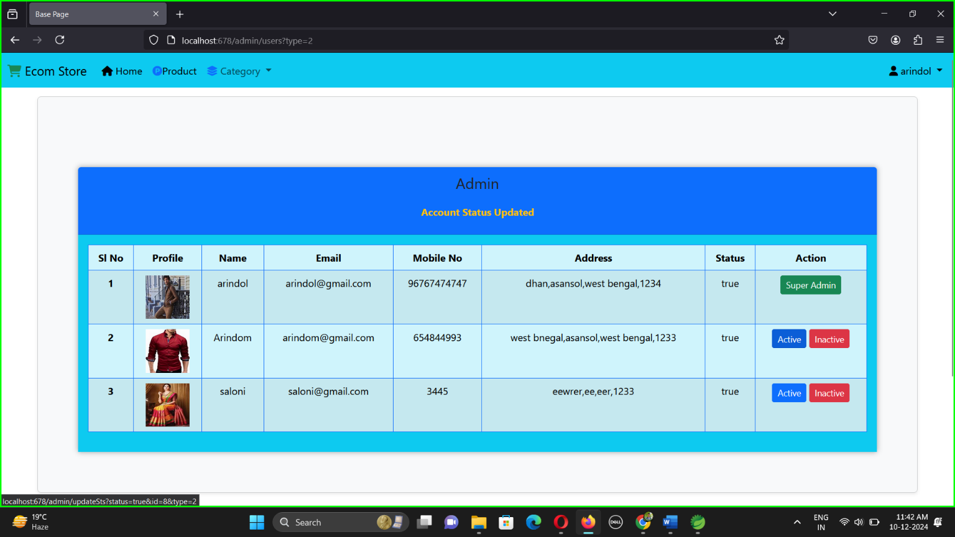

2 **1|** Page

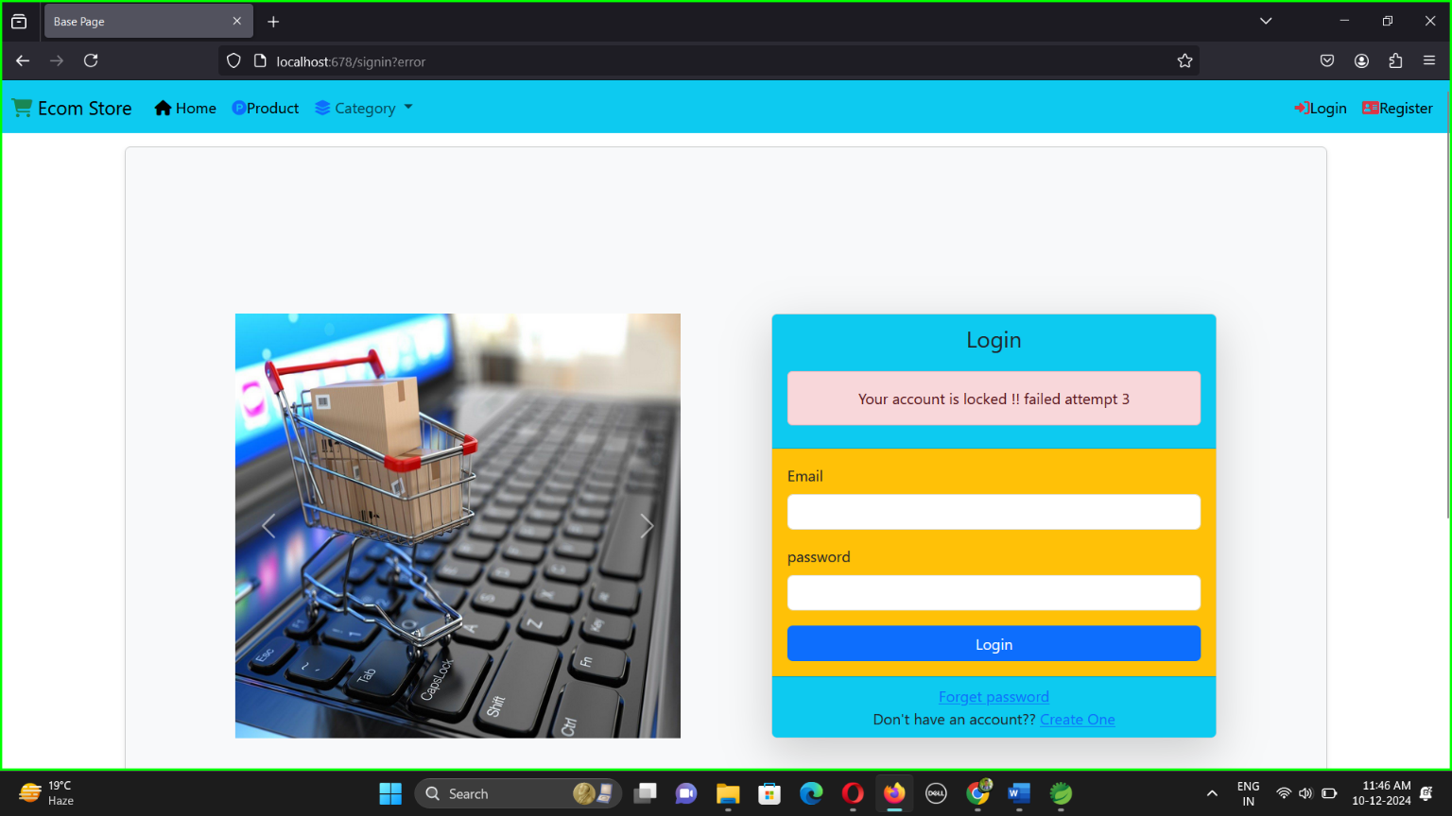

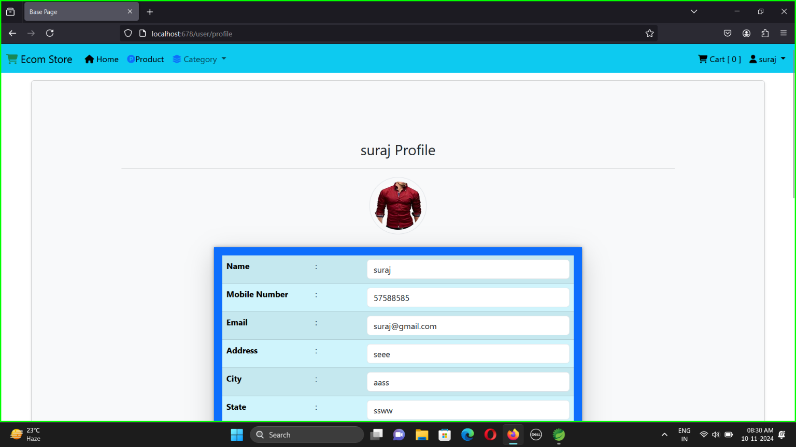

2 **2|** Page

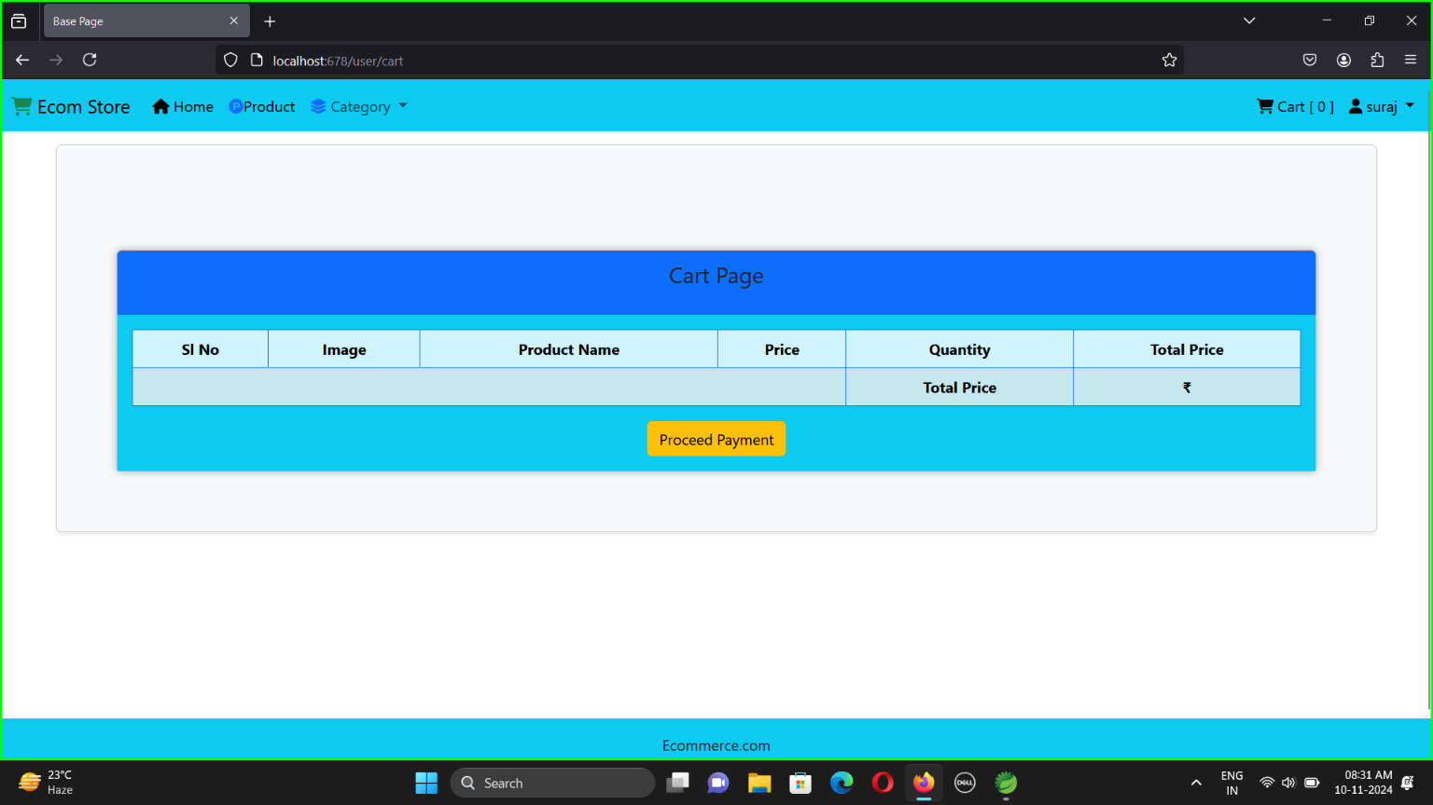

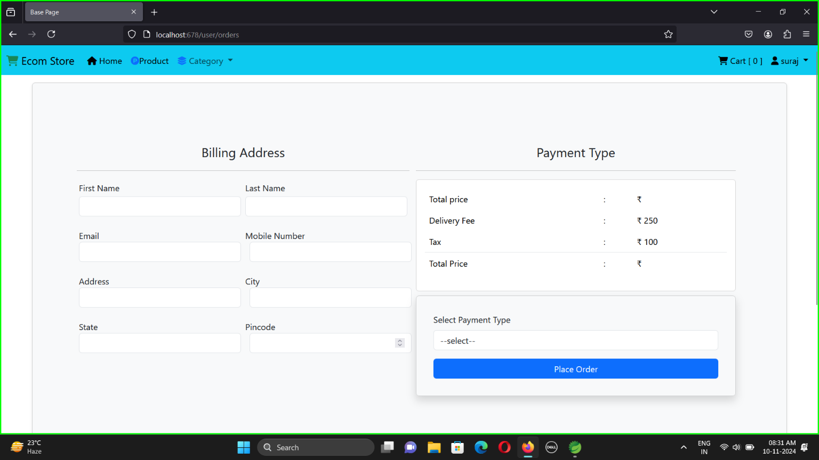

2 **3|** Page

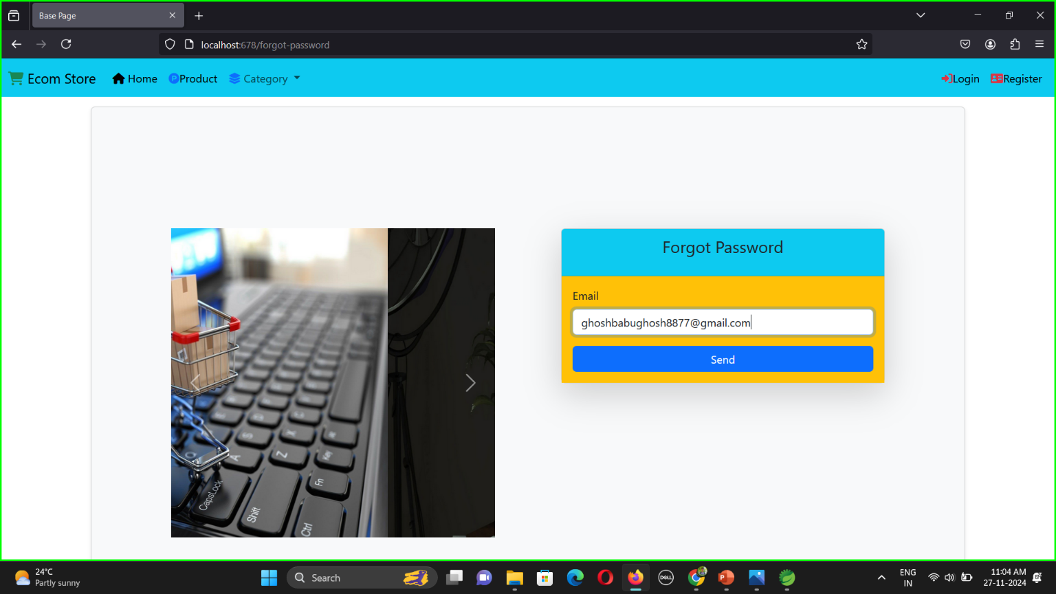

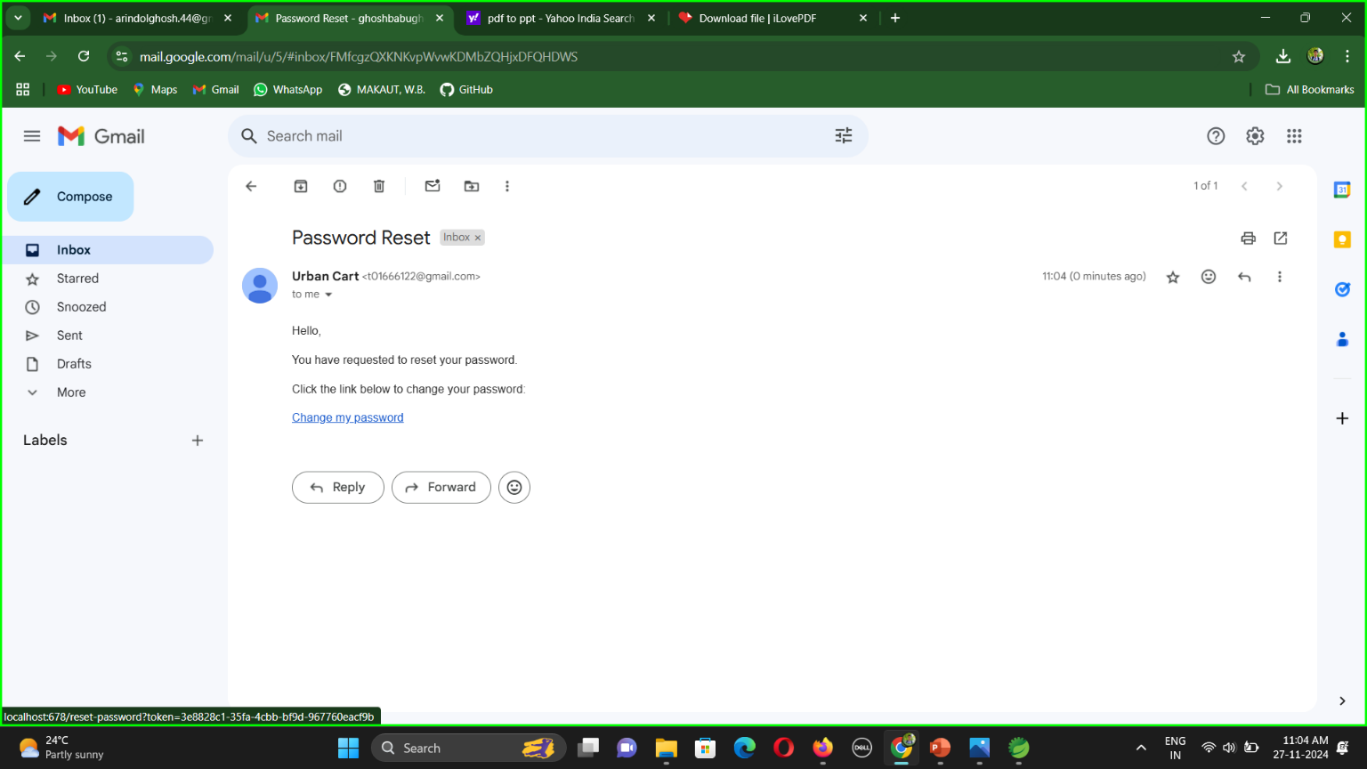

24**|** Page

**Conclusion and Recommendations:-**

The UrbanKart e-commerce project successfully utilized Spring Boot, HTML, CSS, and JavaScript to develop a user-friendly and efficient online shopping platform. By leveraging the strengths of Spring Boot for backend development and HTML, CSS, and JavaScript for frontend design, the platform offers a seamless user experience, robust functionality, and scalability. Key features such as secure authentication, shopping cart management, dynamic order processing, and real-time payment integration were implemented effectively. The project underscores the value of combining modern web technologies with a well-structured backend to meet user demands and business requirements.

Recommendations

1. Enhance User Experience:
   * Introduce AI-based product recommendations tailored to user preferences and behavior.
   * Implement dynamic filtering and sorting options for a more personalized shopping experience.
2. Improve Performance:
   * Use caching mechanisms such as Redis to optimize page load times.
   * Adopt database indexing to improve query execution speed.
3. Expand Features:
   * Add real-time notifications for order status updates and promotional offers.
   * Integrate a robust review and rating system to build user trust.
4. Strengthen Security:
   * Employ advanced authentication methods like OAuth2 and two-factor authentication (2FA).
   * Conduct regular security audits to identify and mitigate vulnerabilities.
5. Future Scalability:
   * Transition to a microservices architecture for better scalability and maintenance.
   * Leverage cloud services like AWS or Azure to handle increased traffic and storage needs.

**References**

1. **Spring Boot in Action** by Craig Walls, ISBN: 978-1617292545
2. **Spring Boot: Up and Running** by Mark Heckler, ISBN: 978-1492076988
3. **Spring Microservices in Action** by John Carnell, ISBN: 978-1617293986
4. **Pro Spring Boot 2** – [Start Spring](https://start.spring.io/)
5. **Spring Boot Cookbook** by Alex Antonov, ISBN: 9781785289118
6. **GeeksforGeeks** – [Data Flow Diagram](https://www.geeksforgeeks.org/what-is-dfddata-flow-diagram/?ref=gcse_ind)
7. **JavaTpoint** – [Spring Boot Tutorial](https://www.javatpoint.com/spring-boot-tutorial)

25 **|** Page